Do Unrelated visual stimuli effect the retention of audible information
1903299 Connor Murphy
MSc Applied Artificial Intelligence and User Experience

PSY555: In What Ways Are We All The Same?

Dr. P George Lovell
October 9, 2024

Do Unrelated Visual Stimuli effect the Retention of Audible Information
Over the last 5 years, online video entertainment has seen a noticeable change with the introduction of “shorts”. Videos between 30 seconds to a few minutes consisting of blogs and clips from TV, podcasts and the like. Within these shorts an interesting phenomenon is seen. In order to keep viewer retention, the creators of the shorts have started to include unrelated videos into the shorts. This addition is most commonly in the form of a mobile game being played. This has had a proven positive effect with these creators seeing growth in their followers. This concept is also seen being pushed in the viewer retention centered algorithms of video sharing sites like TikTok and YouTube.
It has long been known that audio and visual data are processed in distinct parts of the brain, the auditory and visual cortex. However, thanks to Goodale and Milner’s work on the two visual pathways (Goodale, M. A., 2008) it is widely accepted that both audio and visual data are passed and mixed along these two streams to the temporal and parietal lobes in ways we still do not quite understand. However, a paper by Jeremy D Thorn conducted an experiment where participants were asked to confirm whether the last tone in a given string of tones were higher or lower frequency than the last, while an unrelated bar was shown on screen to coincide with these tones. Thorn found that “Task-irrelevant information in one sensory modality can improve performance in another.” (Thorne, J. D, 2008) Suggesting that there could be a beneficial effect when retaining information with an unrelated stimulus
In this proposed study the aim is to verify if this hypothesis can be implemented and provide benefits for real-world scenarios. In order to validate this hypothesis a simulated short will be created and a watcher will be asked how well they remember the short. The expected result according to Thorn is that there should be better information retention with unrelated content is included.

Method
To prove this hypothesis the following experiment is proposed. A participant will be shown a video containing audio on a short lecture on a given subject (The Lecture) however, the visuals of the video will be an unrelated but engaging clip (The Distraction). After the participant has watched the video, they will be asked to select key words and topics from a given list that match the previously observed lecture. The correct number of key words entered acting as a scale for how well the participant retained information. There are several problems that will have to be addressed for this experiment to work. Firstly if the participant is acquainted with the subject of the lecture beforehand, they would not engage with the lecture but still give correct key words. To solve this, the lecture will be on an archaic subject that is highly likely to be unknown to the participant. However, the participant should still be engaged with the subject matter. Examples of subjects could be old European folk stories, ancient civilizations or little-known authors.
Another issue is the length of the lectures; if they are too short the participant can’t engage and retain enough information to extract key words. Conversely if they are too long the participant could lose interest, but, if the hypothesis holds true the distraction could help them to retain information. So, to fully test the hypothesis the lectures should also have varied length, a minimum of around a minute as this is the standard length of shorts on TikTok and Instagram. With the maximum being below 10 minutes to stop the experiment running too long and the participant losing interest in the whole experiment.

Design
The experiment discussed above, by its nature is a between subjects experimental study. The issue of previous knowledge discussed earlier reinforces this, as information learned from a previous lecture would skew the results of the same lecture at a different length. To solve this issue the stimulus combination of length and type of distraction a pseudorandom procedure should be used. Such as the latin square method, this way given a sufficiently large participant base enough data collection should be achievable.

Independent Variable
The independent Variable as discussed will be the length/ topic of “the Lecture” and the type of “Distraction” shown alongside the audio. For the lecture, there will be three archaic topics discussed. This will result in 9 potential stimuli for the participants to be tested on. The length of the lectures will be 1 minute, 2 minutes and 5 minutes.
The other half of the independent variables will be the content of the accompanying video shown during the lecture “the Distraction.” There will be a video with no content (blank screen), a video containing something akin to live wallpaper and lastly, a video containing actively engaging content.

Dependent Variable
The Dependent variable will be the number of key words correctly selected by the participant.
Participants
There were 10 to 15 participants which consisted of university students, assumed to be well educated. They are aged between 20 to 30 and a mix of English, Scottish and American Nationals, IT literate and presumed to be in good health.

Materials
The participant will be told how the experiment will be run. They will sit down in front of a computer to watch a video with headphones. They will not be told what the subject of the lecture will be to avoid priming. The participant will be allowed to ask questions to clarify how the test will be run. The experiment should be conducted in a neutral room free from any potential distractions. The participant should be left alone to complete the experiment.
As for the content for the lectures, they will be generated using a generative AI such as ChatGPT. The generative AI will be asked to write a lecture on the chosen subjects to a specified length then the scripts will then be fed into a realistic speech generator to obtain the audio. The distraction visuals will be prerecorded gameplay and Live wallpapers, these can both be used freely as they will be obtained under free use and will be looped to achieve the desired length.
The actual experiment will be developed using PsycoPy due to its simple drag and drop experiment creation. Both visual and audio along a specific timeline will streamline the development process. Also with its ability to transform the base code into java it can easily be made available online to a greater number of potential participants. As long as the device used has functioning audio output this experiment can be performed anywhere. An example of the experiment can be seen below ideally is should not take more than 20 minutes to complete.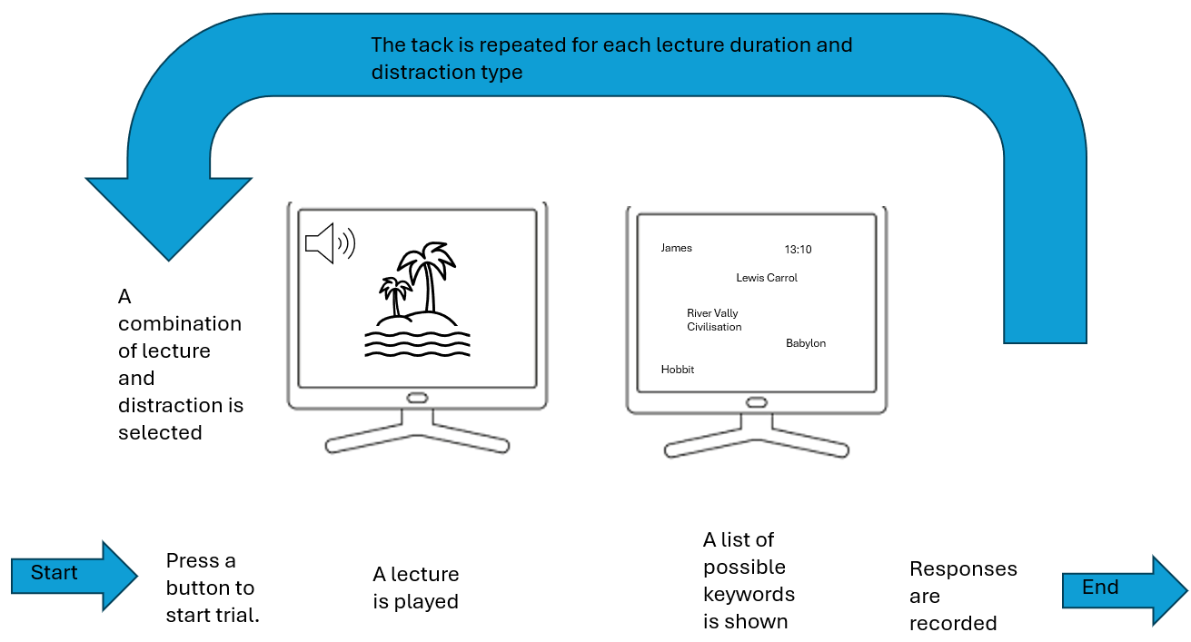
Figure 1 example of single trial of the experiment

Procedure
- The participant will be told to sit down, put on the headphones and to start when ready.
- The participant will listen to the first lecture.
- The participant will be asked to select the appropriate key words.
- Steps 2 and 3 will be repeated twice more to complete for the three lectures along with their distractions.

Data Processing
The data gathered by PsycoPy during the experiment will be collated into a CSV file for further processing. From here the data can be opened in Excel to be further explored and used to generate the appropriate data in graph form.
Declaration
No form of Generative Ai was used in the creation of this proposal.

References
Milner, A. D., & Goodale, M. A. (2008). Two visual systems re-viewed. Neuropsychologia, 46(3), 774–785. https://doi.org/10.1016/j.neuropsychologia.2007.10.005 Accessed:16/10/2024
Thorne, J. D., & Debener, S. (2008). Irrelevant visual stimuli improve auditory task performance. NeuroReport, 19(5), 553–557. https://doi.org/10.1097/wnr.0b013e3282f8b1b6 Accessed:16/10/2024
‌

‌

